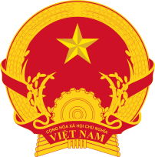
MINISTRY OF INDUSTRY AND TRADE

VIRTUAL CONFERENCE FOR TRADE OF PEPPER AND COFFEE 2021
Date : 27th, 28th, 29th October 2021 (TBC)
Avenue : Virtual, Video (ZOOM, TENCENT) and Facebook
Language : Vietnamese, English, Japanese and Chinese.
Host: Viet Nam Trade Promotion Agency, Viet Nam Trade Offices – Embassy of Viet Nam to foreign countries/regions

27 October 2021
21:00 (EST) Opening room for virtual meeting
21:30 – 00.30 (28 October) | B2B meeting
00:30 – 3:00 | Break
3:00 – 5:00 | Plenary session  - Introduce, advocate the potential and export capacity of coffee and pepper;  - Foreign consumption market profile of coffee and pepper, trade opportunity, consultation for Vietnamese exporters.
5:00 – 9:00 | B2B meeting
28th October 2021
21:00 (EST): Opening room for virtual meeting
21:30 - 00:30 (29 October) | B2B meeting
03:30 – 7:00 | B2B meeting

